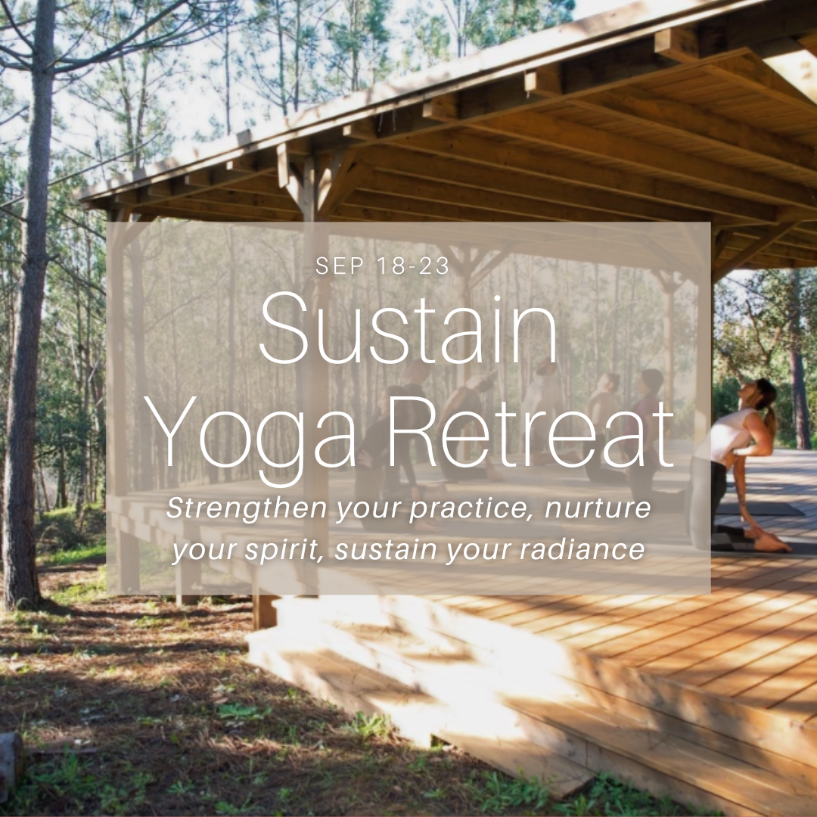

FAQs & Packing List

**ARRIVING AT THE RETREAT**

**Which airport should I fly into?**

The retreat centre is relatively equidistant from both Lisbon Airport (LIS) and Faro Airport (FAO): approximately 1 hour and 45 minutes.

**Transfers**

We'll try to coordinate shared transfers to keep travel costs manageable.**Before booking your flights, please get in touch with us** to discuss transfer options. We'll do our best to find the best solution for you, considering any shared transfer possibilities and individual needs.

Here are the retreat centre's transfer prices (one way):

* €260 for 1 to 3 people
* €300 for 4 to 7 people

For a budget-friendly option, you can take the bus from Lisbon's Sete Rios station (LIS) to Cercal do Alentejo. Tickets are around €16 each way, plus a potential €10 Uber from the airport to the station. We can arrange pick up from the village upon arrival. This option takes longer, so factor that in when booking and the bus schedule. Check the Schedule here <https://rede-expressos.pt/pt/horarios-bilhetes>

**WEATHER**

**What should I expect in September?**

September in Portugal is generally warm and sunny, with average highs around 24ºC and lows around 16ºC. While mornings and evenings can be pleasantly cool, afternoons can still get quite warm.

**Be prepared for:**

* Warm days with occasional cooler evenings
* Light rain showers (possible)
* Strong sun

**Pack:**

* Light, breathable clothing
* Layers for cooler evenings
* Light rain jacket
* Sun hat and sunscreen

We recommend checking the forecast closer to your arrival date for any updates.

**FOOD & DRINK**

**What's included?**

We'll provide delicious, healthy vegetarian meals made with fresh, seasonal, and local ingredients. Please inform us about any allergies or dietary restrictions **as soon as possible** to ensure we can meet your needs.

**LOCAL ACTIVITIES**

**What's around the retreat centre?**

**The Property**

* 4 ha (9 acres) of land to wander and explore
* Outdoor secluded lounge areas
* Pool
* Gym
* Sauna in the forest
* Walking/running circuit
* 12 minutes walking from town
* Access to several hiking trails
* 15 minutes drive from the beach

**Explore Alentejo**

**Beaches:** Explore the coastline. There are so many beautiful beaches to discover!

**Nature Activities:** Hike, bike, or horseback ride through the stunning Alentejo landscape. Trails are accessible right from our doorstep!

**Culture & History:** Immerse yourself in the rich history and architecture of Cercal and nearby towns. Many interesting villages are within a 15-20 minute drive.

**Food & Wine:** Visit local markets, artisans, wineries, cheesemakers, and organic farms. Savor the local flavors and support sustainable practices.

**Optional Activities** (not included in the retreat price):

* HIKING (free)
* GUIDED HIKE (upon request)
* BIKING RENTAL: €15 per half day
* MASSAGE: €85 for 1 hour
* SURF CLASS (including material rental, excluding transportation): €50 per person or learn with Amy for free - Just pay for board and wetsuit rental €25
* STAND UP PADDLEBOARD RENTAL (excluding transportation): €45 per person
* HORSE RIDING (guided): €85 per person
* WINE TOUR + WINE & TAPAS TASTING: €60 per person (excluding transportation)
* WORKSHOPS (Photography/Cooking/Ceramic): offered upon request
* TRANSFERS FROM LISBON/FARO: €260 (1-3 people) or €300 (4-7 people) - one way

**WHAT'S NOT INCLUDED**

* Flights
* Transfers to/from the retreat center (unless arranged)
* Any excursions or treatments not included in the itinerary
* Spending money for snacks, drinks, souvenirs, etc. (Euros recommended)

**WHAT TO BRING**

**Packing List**

**Clothing:**

* A cardigan or scarf for cooler evenings
* Sneakers or comfy shoes for hiking
* Swimsuit
* Hat
* Sunglasses
* Yoga clothes (including a sweater and long leggings for cooler mornings)

**Accessories:**

* Journal
* Mosquito repellent
* Reusable water bottle
* Some cash (EUR) - While most places accept cards, some shops in town may only accept cash. Cash is also preferred for tipping staff.

**What you don’t need:**

* Pool towels, we have them
* Yoga Mats, we have them
* Soap, shampoo, conditioner, body lotion–you ́ll find a natural organic selection
* Hairdryer – we have it